A Mini Project Report
on
COOL CAB BOOKING SYSTEM
by

Akshay Neurgaonkar (T223037)
Tejas Inamdar (T223020)
Ravikant Rathod (T223048)

Under the guidance of
Prof. Aniruddha Kshirsagar



Department of Computer Engineering
ZEAL College of Engineering and Research, SAVITRIBAI PHULE PUNE UNIVERSITY
2020-2021
Department of Computer Engineering
ZEAL College of Engineering and Research,

Date: 26/01/2021

CERTIFICATE

This is to certify that,
Akshay Neurgaonkar (T223037)
Tejas Inamdar (T223020)
Ravikant Rathod (T223048)

of class T.E COMP; have successfully completed their mini project work on “COOL CAB BOOKING SYSTEM’’ at ZEAL College of Engineering and Research, Pune the partial fulfillment of the Graduate Degree course in T.E at the department of Computer Engineering, in the academic Year 2020-2021 Semester – I as prescribed by the Savitribai Phule Pune University.

Prof. Aniruddha Kshirsagar Dr.Sunil M.Sangve
Guide Head of the Department
(Department of Computer Engineering)

Acknowledgements

I would like to express our deepest appreciation to all those who provided us the possibility to complete this report. A special gratitude to our third year mini project mentor,
Prof. Aniruddha Kshirsagar whose contribution in stimulating suggestions and encouragement, helped us to coordinate and complete our project especially in writing this report.
Furthermore, I would also like to acknowledge with much appreciation, the crucial role of the staff of ZCOER, who gave the permission to use all the resources and other necessary materials to complete the project, 'COOL CAB BOOKING SYSTEM'.
I shall also thank deep heartedly to the Course HOD of BE-CSE Mr. Sunil Sangve, who have invested his full effort in guiding the team in achieving the goal of concluding the project with a satisfactory note.

Akshay Neurgaonkar (T223037)
Tejas Inamdar (T223020)
Ravikant Rathod (T223048)

i
Contents

Sr. No. | Topic |  | Page No.
 | Acknowledgement |  | i
 | Contents |  | ii
 | List of Tables/Collections |  | iii
 | List of Forms |  | iv
 | Acronyms |  | v
 | Abstract |  | vi
Chapter-1 | Introduction |  | 1
 | 1.1 | Motivation | 1
 | 1.2 | Problem Statement | 3
 | 1.3 | Framework of the proposed work in project | 4
Chapter-2 | Literature Review |  | 5
 | 2.1 | Introduction | 5
 | 2.2 | Existing methodologies | 8
 | 2.3 | Proposed methodologies | 9
Chapter-3 | Software Requirement Specification |  | 10
 | 3.1 | Hardware Requirements | 10
 | 3.2 | Software Requirements | 11
Chapter-4 | Assumptions |  | 12
Chapter-5 | Entity-Relationship Diagram |  | 13
Chapter-6 | Tables / Collections |  | 14
Chapter-7 | Forms/jFrames |  | 17
Chapter-8 | Features |  | 26
Chapter-9 | Conclusion |  | 30
 | References |  | 31

ii
List of Tables

Table No. | Title | Page No.
6.1 | Login database Table | 14
6.2 | Route details table | 14
6.3  6.4  6.5  6.6 | City details table  User details table  Admin llogin data detail table  Travel bill table | 15  15  16  16

iii
List of Forms

Figure No. | Title | Page No.
7.1 | Level 0 diagram | 17
7.2 | Level 1 diagram. | 18
7.3 | Level 2 Travel finance. | 19
7.4 | Admin use case diagram. | 20
7.5  7.6  7.7  7.8  7.9  7.10  7.11  7.12 | User use case diagram.  Class diagram.  Admin flow diagram.  User flow diagram.  Admin sequence diagram.  User sequence diagram.  Screenshot of welcome page of Cool Cab Booking System.  Main functionality page of Cool Cab Booking System. | 20  21  22  23  24  24  25  25

iv
Acronyms

CBS Cab booking system.

PDA Personal Digital Assistant

GUI Graphical User Interface

SQL Structured Query Language

IVRS Voice Response System

v

Abstract

When it comes to cab rental services, Taxi Service is the most trusted and reliable name in the travel business. The most advanced travel agents offering cab rental and car hire in India, making full use of information technology to improve the level of our efficiency. However, this is only one aspect of services. And this project continually strives to offer the best of services - both in terms of man and machine, to our clients Moreover, this project has a fleet of cars ranging from luxury to budget cabs. While, it offers cab hire service for corporate houses. And this project claims to offer the best of rates, which are tailor-made depending upon the facilities, availed and offer both intercity and intra-city cab facilities. All cabs have proper permits and documentation so that the clients couldn't be hassled for the lack of documents. However, this project has strategic backup system for any eventuality. The cab service includes all categories of cars from luxury to budget.
Further, this project’s utmost priority is quality. To achieve this, vehicles are well maintained and tested for delivering optimum and uninterrupted performance. Team of professionals in the travel business enables this system to design trips that suits to all budgets and preferences of the travelers.

vi

Chapter 1
Introduction
- Overview
This chapter is organized as follows. Section 1.1 describes the motivation of the project for describing its introduction. This introduction helps in understanding the project. Section 1.2 explains the problem statement of the project. Framework of the proposed work in the project are presented in section 1.3.
  - Motivation

Cab Booking System specializing in Hiring cabs to customers. It is a system
through which customers can view types cabs; register the cabs, view profile and book
cabs.Cab booking service is a major transport service provided by the various transport
operators in a particular city. Mostly peoples use cab service for their daily transportations
need. The company must be a registered and fulfils all the requirements and security
standards set by the transport department.

Cab Booking System is a desktop based platform that allows your customers to book
their taxi's and executive from the comfort of their own home or office. The
platform should offer an administration interface where the taxi company can manage the
content, and access all bookings and customer information. More and more Taxi companies
are looking for integrated taxi booking systems as it makes life much easier for (1) The
traveler - this is highly important and in today's internet age people should be able to book
taxis without having to pick up the phone and (2) the taxi company as all their
bookings are now managed via an automated system which means they have an electronic
record of future and historic bookings

A Cab Booking/Hiring is a system that can be used temporarily for a period of time with a
fee. Hiring a car assists people to get around even when they do not have access to their
1
own personal vehicle or don't own a vehicle at all. The individual who want to hire/rent a
car must first contact the cab hiring company for the desire vehicle. This can be done
through app. At this point, this person has to supply some information such as: dates of rental,
and type of car. After these details are worked out, the individual renting the car must

present a valid Identification Card. Most companies throughout the industry make a profit
based of the type of cars. The hiring cabs are categorized into economy, compact, compact
premium; premium and luxury & customers are free to choose any car of their choice based
on their purse and availability of such car at the time of reservation.

This Car Booking system project is written in Python. This is a simple GUI based application which is very easy to understand and use. It uses Tkinter module for the GUI. Talking about the application, the user can easily book, view, update and delete appointments.

We aim to become a pioneer in the vehicle rental industry by completely focusing on customers, our employees, growth, innovation and efficiency. All of these elements will drive us towards success and show us as one company that can perform and give value for money.

2
1.2 Problem Statement

The old manual system was suffering from a series of drawbacks. Since whole of the system was to be maintained with hands the process of keeping, maintaining and retrieving the information was very tedious and lengthy. The records were never used to be in a systematic order. there used to be lots of difficulties in associating any particular transaction with a particular context. If any information was to be found it was required to go through the different registers, documents there would never exist anything like report generation. There would always be unnecessary consumption of time while entering records and retrieving records. One more problem was that it was very difficult to find errors while entering the records. Once the records were entered it was very difficult to update these records.

- Objectives
¬ To keep the information of Customer.
¬ To keep the information of number of bookings.
¬ To keep the detail of taxis route.
¬ To keep the information of cancellation and modification of booking.
¬ To maintain the record of every employee of every route.

A desktop based management system is designed to handle the entire primary Information required to manage the whole data. Separate database is maintained to handle all the details required for the correct statement calculation and generations. This project intends to introduce more user friendly in the various activities such as record updating, maintenance, and searching. The objective and scope of our project Online Cab Hiring System is to record the details various activities of user. It will simplify the task and reduce the paper work. To produce a desktop-based system that allow customer to register and reserve cab online During implementation every user will be given appropriate training to suit their specific needs. Specific support will also be provided at key points. Training will be provided on a timely basis, and you will be trained as the new is Cab Hiring System rolled out to your area of responsibility. To produce a system that allow customer to register and reserve cab and for the company to effectively manage their Cab hiring business. To ease customer’s task whenever they need to rent a cab or hire a cab.

3
  - Framework of the proposed work in project

- Programming lang. : Python3 is used for the programming of the application & for all functionality and backend to gui.
- Tkinter library: it is used for frontend and gui of the projects. From that library the listboxes,frames,dropboxes,entries,buttons etc. like and many other functionalities are imported & used.
- Sqlite3 database : It is used for the database. Which you need to download first from the pyorganisations/. Using this sqlite3 database data is stored in the tabular format.
- DB browser: It is used for the monitoring of the data at the time of login and other time too.

- Software framing:
Software design sits at the technical kernel of the software engineering process and is applied regardless of the development paradigm and area of application. Design is the first step in the development phase for any engineered product or system. The designer’s goal is to produce a model or representation of an entity that will later be built. Beginning, once system requirement has been specified and analyzed, system design is the first of the three technical activities -design, code and test that is required to build and verify software. The importance can be stated with a single word “Quality”. Design is the place where quality is fostered in software development. Design provides us with representations of software that can assess for quality. Design is the only way that we can accurately translate a customer’s view into a finished software product or system. Software design serves as a foundation for all the software engineering steps that follow. Without a strong design we risk building an unstable system – one that will be difficult to test, one whose quality cannot be assessed until the last stage.
During design, progressive refinement of data structure, program structure, and procedural details are developed reviewed and documented. System design can be viewed from either technical or project management perspective. From the technical point of view, design is comprised of four activities – architectural design, data structure design, interface design and procedural design.

4
Chapter 2
Literature Review
- Overview
This chapter is organized as follows. Section 2.1 describes the introduction of the literature review of the project for describing nessecities. This introduction helps in understanding the project. Section 2.2 explains the existing methodologies of system. Information about proposed methodologies is presented in section 2.3.
2.1 Introduction
Actual cities are oversaturated, on one hand most of the population is concentrated in large
cities (in 2030 more than 80% (UNFPA 2007) of the population will live in urban areas),
on the other hand mobility needs of the modern population are growing continuously.
While urban demand for trips is growing constantly, supply (capacity of city streets) is
limited, and must be optimized, not increased (most of the times not possible inside the
city). Well-planned, efficiently operated, and cost-effective transportation system
management (TSM) strategies can improve mobility of existing systems for transportation
users, especially in urban environments, where a good optimization of the infrastructure is
needed (considering the high cost of building new facilities and the continuously
increasing demand resulting from economical and population growth). Last years
tendencies are shifting person trips from private vehicles to public vehicles, increasing the
Public Transport share importantly. The most used Public Transports are the “Mass
Transports” such as metro, tram or bus. This kind of transport usually has a centralized
management which uses ITS technologies developed in the last decade for an optimal
operation of the service.

Unfortunately, inflexibility, long total travel time and insufficient service coverage of
Mass Transport systems cause a lower usage of them in most metropolitan areas.
Oppositely, the taxi-cab sector is a more convenient mode due to its speediness, door-todoor
attribute, privacy, comfort, long-time operation and lack of parking fees. The great
5
Josep Maria Salanova et al. / Procedia Social and Behavioral Sciences 20 (2011) 150–161
151 inconvenience is the lack of central management; each taxi is operated by an
independent driver, taking his own decisions continuously, with a weak intent of control by
the policy issues of each city such as license control or distributing the working days of the
taxi vehicles (normally the control is imposed on vehicles, not on drivers, generating
double shift and increasing the use of taxis). An important percentage of the cars (e. g.
60% in Hong Kong (Yang et al. 2000)) in the daily flow are taxis, most of them empty
taxies. This situation is creating two problems, an internal problem to the taxi drivers
(higher empty kilometers means lower benefits) and an external problem to the citizens
(congestion and pollution). The first problem is being aggravated with the actual economic
crisis, which is breaking the market equilibrium: demand is decreasing due to the lower
incomes of the population and offer is increasing due to the increasing number of taxi
drivers (not taxi licenses). Market equilibrium cannot be achieved in this concrete market
because of the regulations (price is not established freely), and cannot go to the next
equilibrium point due to the price policies imposed in each city. This is a vicious cycle,
where empty hours are increasing, and taxi drivers need to work more time in order to have
the same income, which means lower income per hour (Daniel (2006)). In this situation,
taxi drivers prefer to stop at taxi stands and wait for a client, without expending fuel in
empty trips and consequently saturating the taxi stands. If taxi stops network is not well
designed, this situation will create a decrease in the Level of Service of the passengers,
decreasing the demand and congesting the streets near the taxi stops.

The taxi sector has been traditionally a regulated market in terms of fares and entry
control. The objective of this regulation is to correct the defects of the taxi sector, such as
externalities (congestion and contamination), low level of service offered and
anticompetitive behavior of the market. A fundamental distinction in types of taxi
regulations is between quantity regulation, quality regulation and market conduct
regulation.
Restrictions on entry to the taxi market have been applied by many cities around the world, but actually many cities are deregulating their markets. The most common justifications used for controlling the
entrance to the taxi market are the protection of the taxi drivers incomes and the
externalities (pollution and congestion) caused by the circulating taxis, but when decisions
are taken without a good justification or implementation plan, entry restrictions and fare
6
regulations are distorting economically the taxi sector, leading to important welfare losses.
As a result of entry control, the price of the licenses in markets where taxi licenses are
tradeable are higher (Paris 125.000 €, Sydney 300.000 $, Melbourne 500.000$, New York
600.000$ [OECD 2007]), and they are rising up constantly due to the exploitation of their
owners. Reforms have often been opposed to reduce the incomes of drivers, which are
normally low, and restrictive conditions have been applied in this direction, but there is no
evidence that taxi incomes are higher in markets with regulated entry conditions.
Oppositely, license owners is the group who is being beneficiated by these measures, and
not the drivers.

Deregulation has most of the times positive impacts, resulting in lower waiting times,
increased consumer satisfaction and price falling (OECD 2007). Market liberalization is an
interesting challenge for many cities, but in cities where strong supply restrictions have
been applied, there will be a strong opposition to reform proposals from the licenseowners.
Arguments support that license-owners must be compensated in that case: one
approach (first used in Ireland) is to give the additional licenses to each license-owner,
ensuring that the new monopoly will remain in their hands; alternatively the new license
can be given to taxi drivers without taxi license (OECD 2007). In Melbourne, a 12 year
program is adding to the stock of licenses a number of licenses equal to the yearly demand
growth. Other concepts are important in relation to deregulation, most of the times quantity
deregulation means quality regulation, ensuring safety and minimum service standards.

7
2.2 Existing Methodologies

Cool cab Service is an innovative thought to simplify the Transportation problems of
Employees of an organization. In the present System, Organization do maintain a person
for the allocating and proper functioning of transportation. The Person appointed needs to
look after the assigning and movement of cabs.Authorized person maintains the
transportation details in papers, which is a tedious task if any updations or changes need to
be done.

➢ Details are stored in Papers.
➢ Maintenance is a huge problem.
➢ Updation, changes in details is a tedious task.
➢ Performance is not achieved up to the requirements.

8
2.3 Proposed Methodologies

In the Previous System, Details are Stored Manually in papers, to share the details between
employees was a Financial drawback. Updations in the details is a tedious task.But a new
system was proposed to overcome the above drawbacks.

Functionalities and advantages of proposed system are:

➢ Data is Centralized which has overcome the Sharing problem in previous system.
➢ As data is Maintained electronically, it’s easy for a person to update the details,
which has overcome the tedious updation in previous system.
➢ Maintenance is easy and performance is good.
➢ Mainly the system has automated the Transportation Process.

9
Chapter 3
Software Requirement Specification

- Overview
This chapter is organized as follows. Section 3.1 describes the minimum hardware requirements needed for the project . This helps to run the project accordingly. Section 3.2 explains the software requirements to run the project.

3.1 Hardware Requirements

Processor:
Intel / AMD / ARM Processor, 1Gz or better (Minimum)

RAM:
2GB (Minimum)

HDD:
160 GB, 7200k spin (Minimum)
Core:
Dual core (Minimum)

10
3.2 Software Requirements

Front End:
Tkinter

Back End:
Python, Sqlite3 DB

Operating System:
Windows 7/8/10
Runtime Framework:
Microsoft .NET Framework

11
Chapter 4
Assumptions

- Overview
This chapter is organized as follows which describes the asssumptions that are made in project.

* The assumptions in the application include situations like :-
1. The average number of rides in a week for a regular customer be calculated and rewards in the form of discount coupons be awarded.
2. The rider may want to cancel a ride when the driver has already started the ride
3. The driver ends the ride even before reaching the destination
4. The driver follows a different way to reach the destination than the one being shown by the system.

12
Chapter 5
Entity-Relationship Diagram

ER Diagrams
Has
Admin
User

UserName
PassWord
EmailID

FirstName
LastName
Address
Postcode
TelephoneNo
MobileNo
EmailID
Designation
DOB
Age

13
Chapter 6
Tables / Collections

Table 6.1. Login database table.
no | Columnname | Datatype | Constraint
1 | no | INTEGER | PK
2 | Username | TEXT | NOTNULL
3 | Password | TEXT | NOTNULL
4 | fpassword | TEXT | NOTNULL

Table 6.2. Login credentials description table.
Sno | Columnname | Datatype | Constraint | reference
1 | RTID | Int | PK
2 | Routed | varchar(50) | NotNULL
3 | RouteDescription | varchar(50) | NotNULL
4 | Source | varchar(50) | NotNULL
5 | Destination | varchar(50) | NotNULL

14
Tables 6.3 & 6.4. City details and User detail tables.
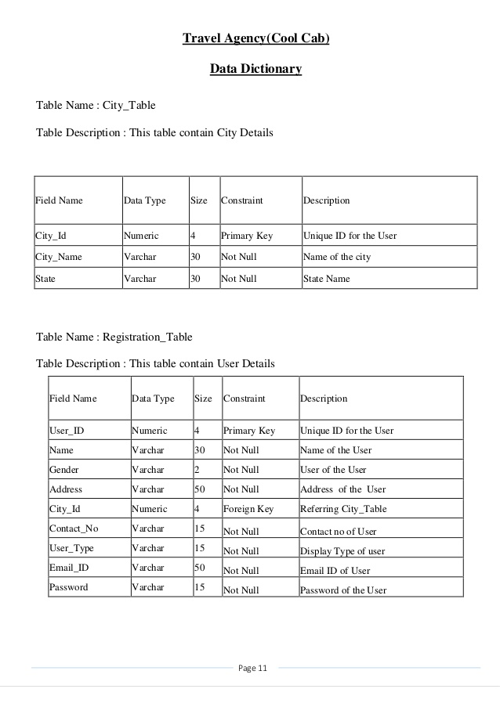
15

Table 6.5. Admin login data detail table.
Sno | Columnname | Datatype | Constraint | reference
1 | AdminID | varchar(50) | Primary key
2 | UserName | varchar(50) | Not null
3 | Password | varchar(50) | Notnull
4 | EmailID | varchar(50) | Allow null
5 | Department | varchar(50) | Not null

Table 6.6. Travel bill table
Sno | Columnname | Datatype | Constraint | Datatype
1 | TID | int | PK
2 | TripSheetID | varchar(50) | Not NUll
3 | AllocationID | varchar(50) | FK | Tbl_VehicleAllocation
4 | VehicleID | varchar(50) | FK | Tbl_Vehicle details
5 | RateKM | varchar(50) | Not NUll
6 | KM | varchar(50) | Not Null
7 | TotalAmount | int | Not Null
8 | Remark | varchar(50) | Not Null

16

Chapter 7
Forms / jFrames

Figure 7.1. Level 0 diagrams.

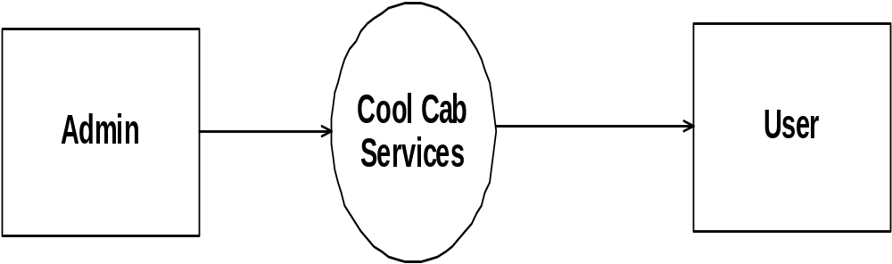

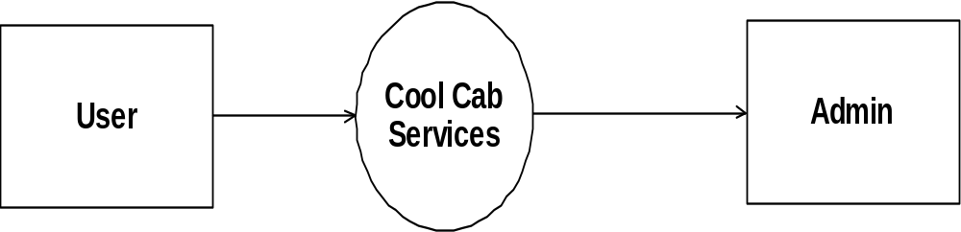

17

Figure 7.2. Level 1 diagram.

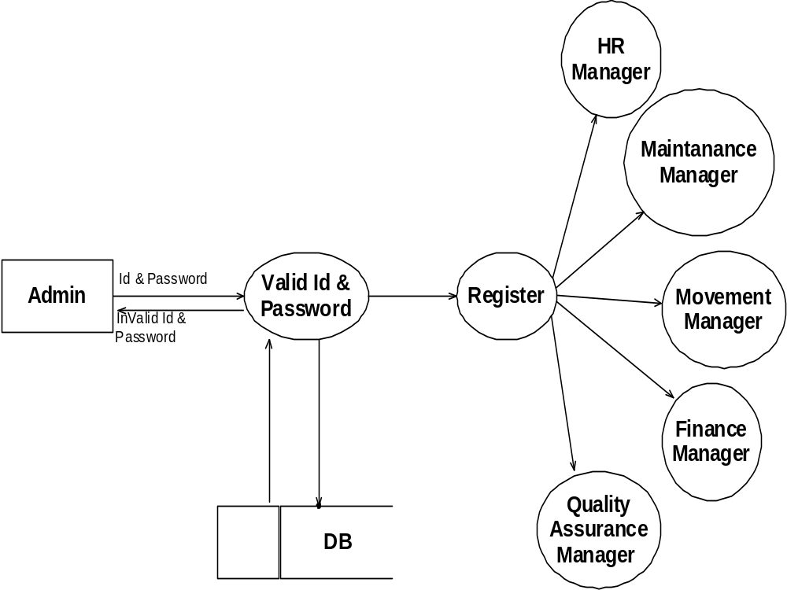

18

Figure 7.3. Level 2 travel finance.

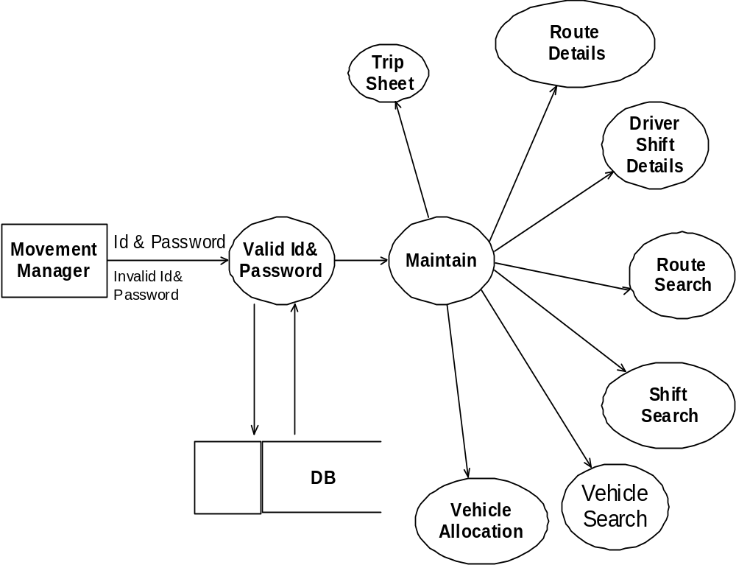

19

Figure 7.4. Admin use case diagram.
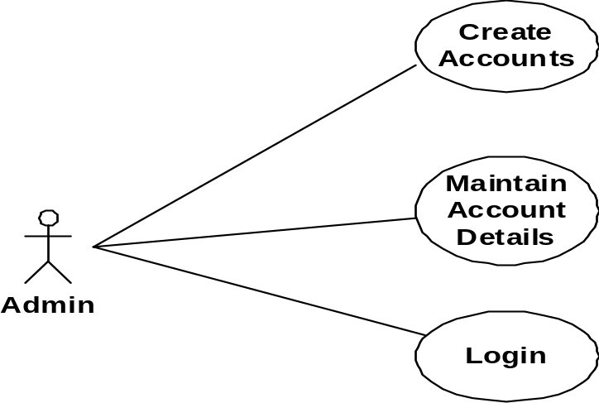
Figure 7.5. User use case diagram.
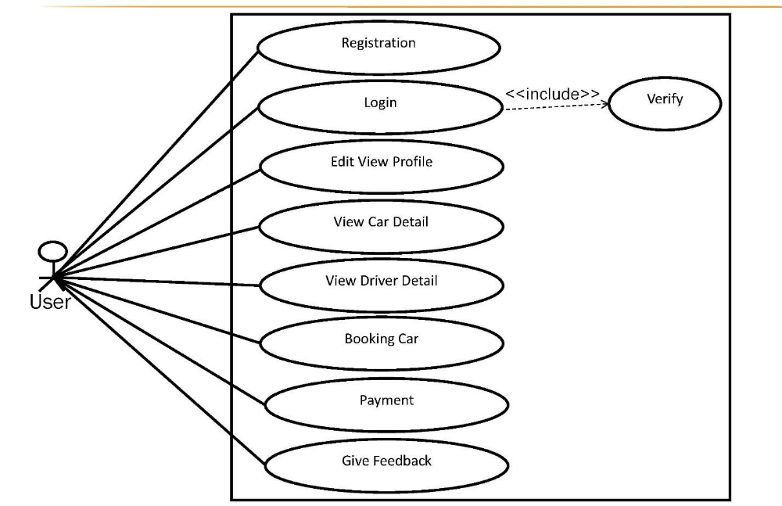

20
Figure 7.6. Class diagram.

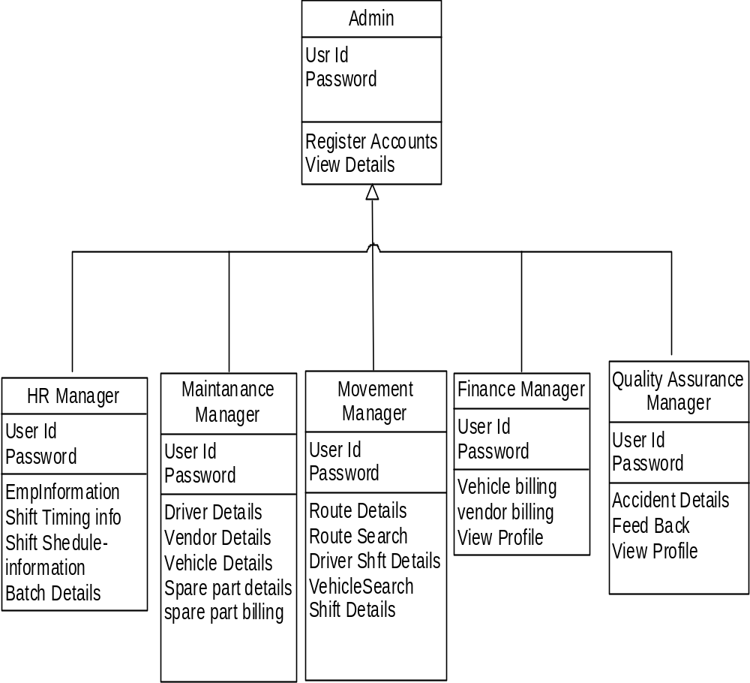

21
Figure 7.7. Admin flow diagram.

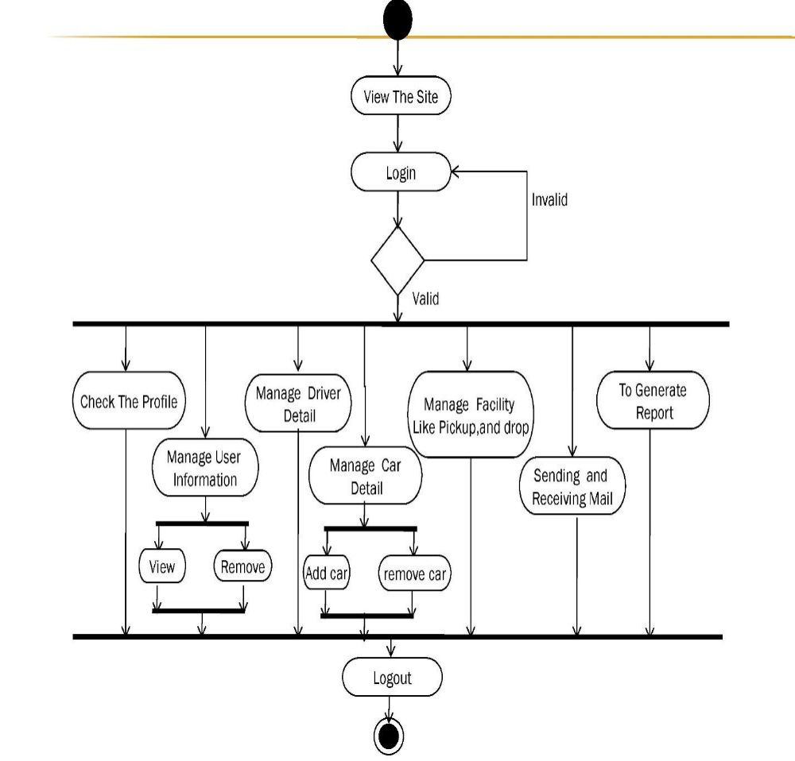

22

Figure 7.8. User flow diagram.

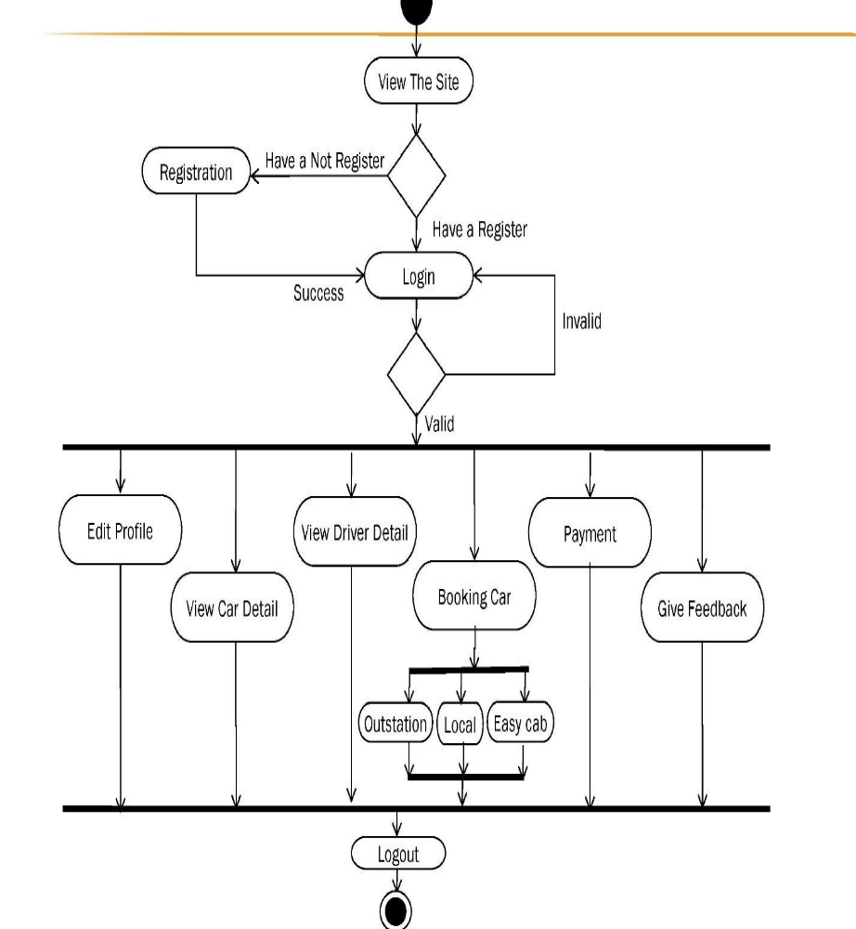

23
Figure 7.9. Admin sequence diagram.
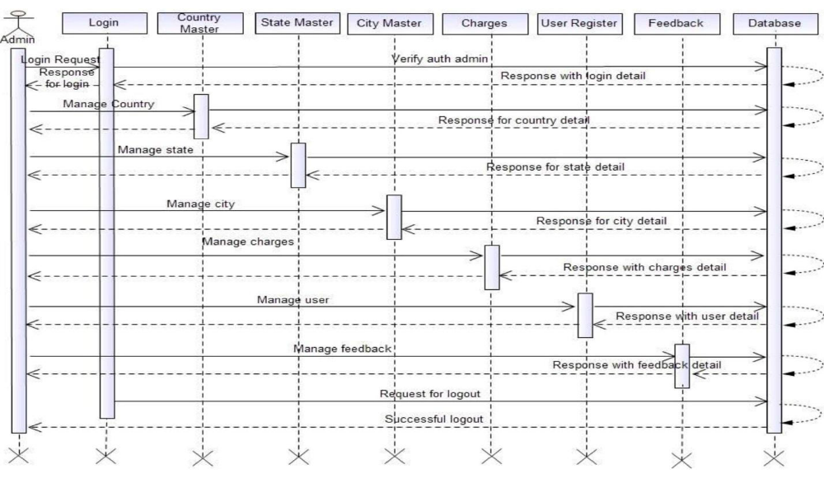
Figure 7.10. User sequence diagram.
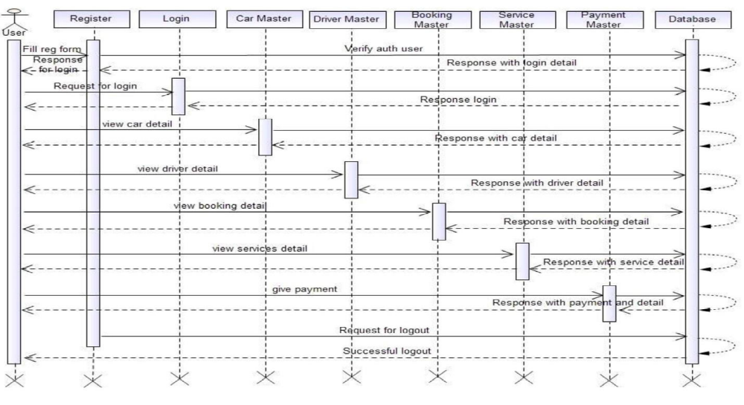

24
Figure 7.11. screenshot of welcome page of Cool Cab Booking System.
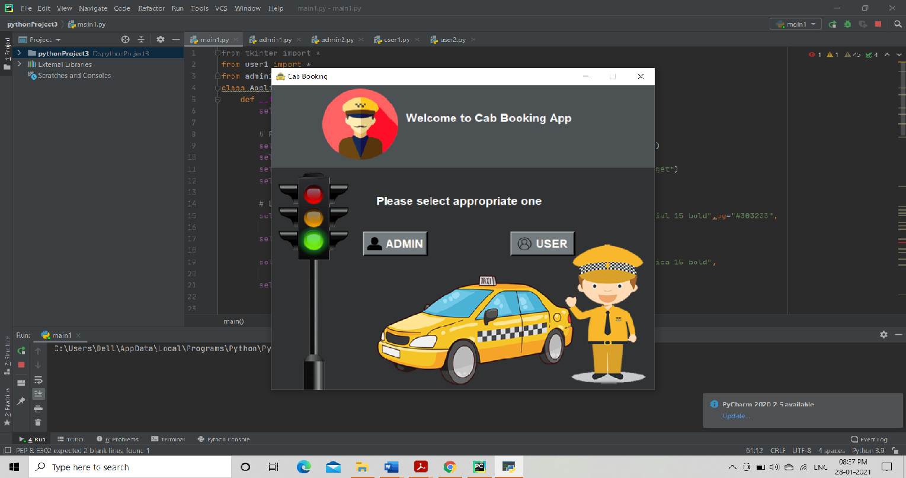

Figure 7.12. Main functionality page of Cool Cab Bookin System.
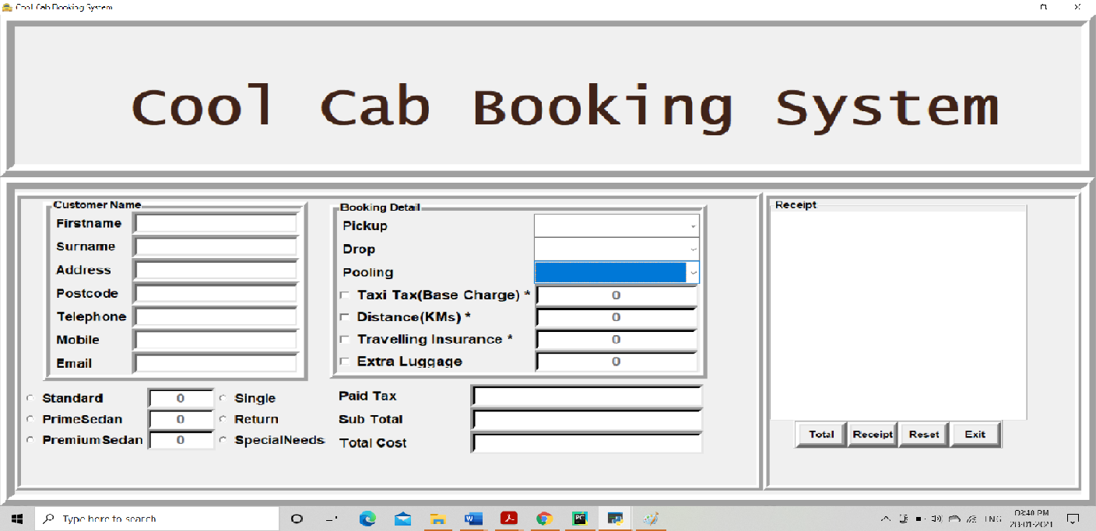

25
Chapter 8
Features
- Overview
This chapter is organized as follows which describes about the main and all other features of the project.

Basic functionality for booking cab
The basic layout of the booking app is interactive and impressive. All the features are well-defined and focused on serving the consumer well and keep in mind their requirements.

Features of Cool Cab Booking System are as follows :

* User-friendly UI
The features of the booking system that appeals to the users most are one where the booking process is conducive to the user.
When booking cabs in a hurry, users are likely to get for something that gets the booking done with a few taps.
The basics are like a search bar for pick up and drop location, selection of a type of ride they want.
This app also have the feature where users can select their locations, say office location, home location, frequented restaurant location, etc.
It saves their time as they don’t have to select locations all the time. App design is directed towards minimalism and time-saving.

26
- Fare precision
This app shows the estimated fare to the user. All apps worth their salt has this feature where the user can before they avail the ride, see how much it’s going to cost them.
Cabs have different rate charts and there are also surge rates. The users always want to see the rate before they avail the service of the cab.
Once the user sets the location for pick up and drop, there is an option where they can see the approximate amount that the journey is going to cost them.
- Cab confirmation
If the user confirms to book a ride right away, the application shows a confirmation screen which shows the detailed information about the ride and rate estimate.
- Cab type preferences
Cab application offer preferences for selecting different types of cabs. For example, The user who wants Economy (Shared Ride, lowest Cost), Premium (Spacious, affordable sedans), More (Compact rental, Local city travel).
- Effortless sign-up process
Users will not be hassle with an elaborate signup process. It don’t ask them for payment details at the time of sign up.
Most people are likely to pay with cash rather than a card or through online money transfer platforms.
Kept signup process simple to help your users face minimum difficulties in the initial process. It has been observed that if users have to go through an elaborate sign-up, they tend to abandon the app altogether at that stage. 27
Asked basic details like –
- Name
- Mobile number
- Email
- Username
- Password

- User-centric booking process
After the successful completion of the user registration process, the app takes the user to the home screen from where they can select their ride by themselves.
There are some noticeable points which are there in a cab booking process –
- Search option to enter a pickup location
- dropbox enabled to take the drop location
- Detailed fare to check the bill

- Ride details through Bill
Once the booking of the ride is confirmed, the application avail the user to see the pickup & drop location of the cab through bill and the estimated distance of arrival along with the other details of the Cab.
For Example –
- Details of the User
- Total amount to be paid
- Distance between pickup & drop location
- Type of the Cab. 28
One more important option is there it is “Reset”, the user can reset or cancel the booked ride before the driver reached the pickup location.
This option can be used if the user has some unavoidable changes in the ride plan.
- Profile Creation
The profile of the User with his/her contact number and Name will help the driver to easily identify the person before they enter the cab.

Most of the people are using apps for easily managing their day to day activities. So it is wise to develop app for your any business to improve the customer relationship and improve the sales of the company.

29
Chapter 9
Conclusion

Conclusion:
Information Technology plays a vital role not only in a particular field, it provides various
kinds of solutions and services to the various problems prevailing in many fields.
Cabs exploits information technology at the maximum extent. It uses the information
technology in an efficient way for providing better passenger services. The online booking
system helps to solve the everyday problems of the world biggest Indian

Limitations:
Cool Cab Services is a python application and it is restricted to only limited type of users. In
this application, Different types of managers have been given access rights and they are
restricted up to their functionalities, so that the data is maintained securely and redundant
data is prevented. As the Data is stored electronically, it is necessary to have a Computer
and Network connection to access the Application. Here The Details of Employees and
Drivers, cabs are maintained but accounts to these people are not created. using this
application manger do assign or update the batch, cabs to drivers and employees.
But employees are unable to view their details.

30

References

1. https://developers.google.com/places/web-service/autocomplete
2. https://developers.google.com/places/
3. https://books.google.co.in/.
4. https://designcode.io/
5. https://www.raywenderlich.com/
6. http://www.appcoda.com/
7. https://www.lynda.com/
8. www.google.com
9. https://pythonbasics.org/tkinter-listbox/
10. http://pythonbasics.org/
11. https://www.python.org/downloads/release/python-350/
12. Josep Maria Salanova et al. / Procedia Social and Behavioral Sciences 20 (2011) 150–161151

31

